Event Report
Activity Report of OSGeo Taiwan of the 5th Taipei International Digital Earth Symposium (TIDES ’07) and FOSS4G.tw Summer Training 2007

OSGeo Taiwan, founded on March this year, is a new and vibrant social network in Taiwan. OSGeo Taiwan actively participated in local GIS-related conferences and meetings to advocate open geo-data, promote Open Source GIS and introduce OSGeo to Taiwanese GIS communities. OSGeo Taiwan further collaborate with Academia Sinica Computer Center GIS Team, and Chinese Culture University Digital Earth Research Center, to organize a session for Free/Open Source Software for Geoinformatics (FOSS4G) at the 5th Taipei International Digital Earth Symposium (TIDES’07) which is held at Chinese Culture University from May 15 to 18. Moreover, OSGeo Taiwan started to conduct Summer Training courses for Open Source GIS on each Friday during June 29 to August 3 at Academia Sinica Computer Center.

A Session for Open Source GIS in TIDES’07
The FOSS4G session in TIDES’07 was conducted on 18th May, during the morning session. There are four talks and a panel discussion in this session. The aims of talks are to deliver introduction of FOSS4G and demonstrate how the FOSS4G works. First of all, Dr. Victor T.S. Horng, general manager of OSS Integral Institute Co., Ltd., gave the attendees a clear and interesting summary for the benefits of using FOSS. Even the advantages of using OSS is obvious, the intellectual property rights issue of the OSS is often doubted in Taiwan GIS communities. Ms. Tung-Mei Ko, project manager of Open Source Software Foundry (OSSF), is familiar with legal topics of FOSS. In her talk, she delivered an overview of FOSS characteristics and the FOSS authorization model. Her experience is useful for encouraging the use and development of FOSS4G in Taiwan.
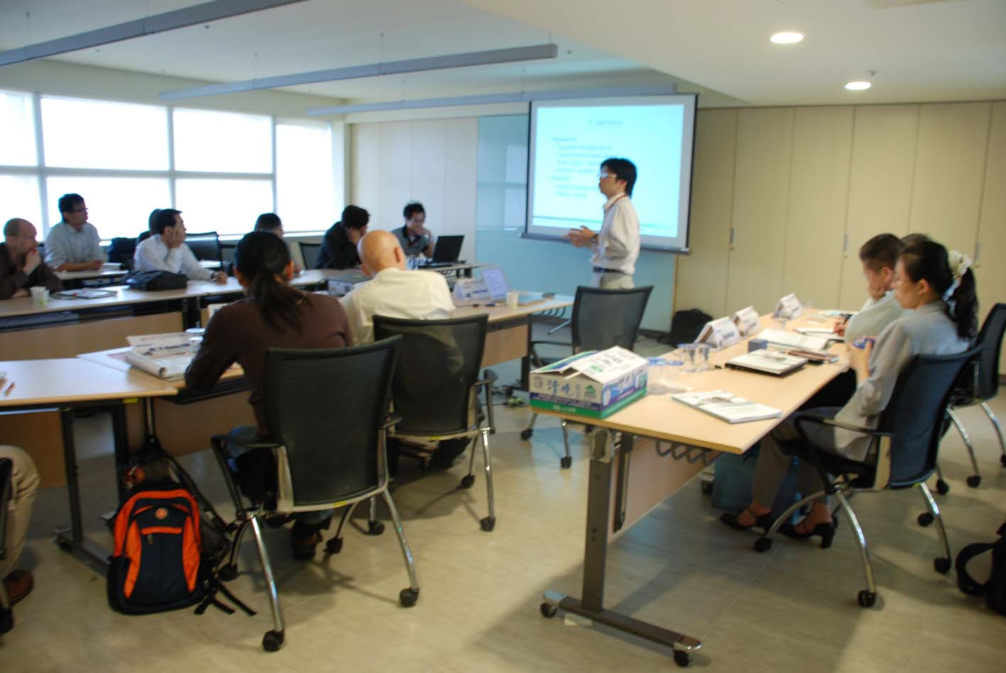
Mr. Hsiung-Ming Liao, initial member of OSGeo Taiwan and project instructor of GIS Term of Computing Centre of Academia Sinica, demonstrated a web-based geospatial application constructed by MapGuide Open Source and Web 2.0 techniques. He considered the development of Geo Web cannot lack FOSS4G and more successful experience of FOSS4G is important to FOSS4G progress in Taiwan. However, the prevailing commercial GIS solutions absorbed the public attention toward alternatives like FOSS4G. There is urgent need to provide more alternatives to deal with geospatial information in Taiwan. The final speaker in this session is Mr. Dongpo Deng who is coordinating and also the initial core member of OSGeo Taiwan. He introduced OSGeo Foundation, global rapidly forming OSGeo communities, and OSGeo Taiwan, with further explanatory discussion of crucial software aspect of FOSS4G. The talk gave the attendees a roadshow of current geospatial open source software applications, guiding them with the freedom of choices of appropriate tools for their own applications.
Figure 1: Dongpo introduced OSGeo Taiwan and gave a tour of FOSS4G
The final panel discussion focused on “Encouraging Development of OSGeo Activities in Taiwan”. Panelists not only shared their experiences of FOSS and FOSS4G, but also provided some suggestions for future development of FOSS4G in Taiwan. Most panelists agreed, Open Data is the first and most urgent task on the list of priorities of OSGeo Taiwan. Enthusiastically discussed by panelists, the OSGeo Taiwan should make concerted efforts to lobby the government releasing the geospatial data and providing useful resources, and co-developing tutorials, technical notes, training courses, workshops and conferences to assist novices of OSGeo & FOSS4G to influence & support local geospatial professional communities. For instance, Taiwan’s Ministry of The Interior Information Center promised to start releasing map data to facilitate the learning and exchange among geospatial communities & industry.

FOSS4G.tw Summer Training
FOSS4G.tw Summer Training is held on each Friday during June 29 to August 3 at Academia Sinica Computer Center, Taipei. The free courses aim to provide technical and practical introduction for beginners, especially students and research assistants. We hope the attendees will use these tools in their homework or projects, gaining a deeper understanding, and we anticipate them to be seeds for future promotion of FOSS4G. The serial courses cover several heavy-weighted applications such as GRASS, PostgreSQL/PostGIS, MapServer, GeoTool and MapGuide, for example. Every instructor has his/her own rich experiences for FOSS4G, and can apply to local scenarios to best demonstrate the usage of it. The series of courses is sponsored by Institute of Information Science, Academia Sinica and Academia Sinica Computer Center.
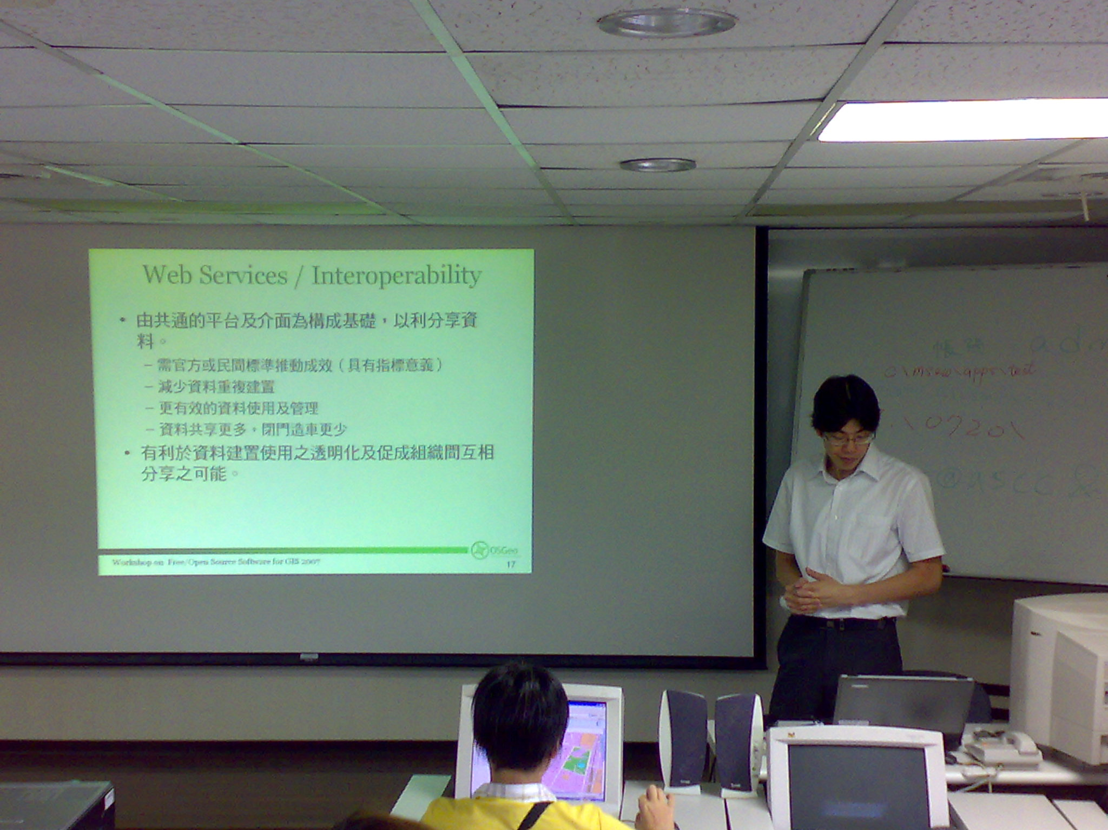
Figure 2: Anthony Yang introduced UMN MapServer at FOSS4G Summer Training
Dongpo Deng
OSGeo Taiwan
dongpo AT iis.sinica.edu.tw

