North Carolina's OSGEO affiliated Open Source GIS user
group holds first meeting at the 2007 NC GIS Conference

Bi-annually, North Carolina GIS professionals hold a statewide GIS conference to showcase their many exemplary projects and initiatives. This year was the 20th anniversary of the NC GIS Conference, one of the nation's oldest state-level GIS events, and had over 900 attendees and 100 presenters.

On March 1st, a small group of dedicated, open-minded GIS professionals led by Dr. Helena Mitasova (of the renowned GRASS project fame) held the first “OSGEO affiliated” NC Open Source GIS user group meeting at the 2007 North Carolina GIS Conference in Winston Salem, NC. http://www.cgia.state.nc.us/ncgis2007

There were approximately 20 attendees, with a majority of the group who signed up for a future listserve being of the University persuasion. There were also a handful of Federal, State and Local Government representatives. Two staff members from an “enormous commercial GIS software provider” also attended, likely performing the requisite surveillance activities.

The short and informal evening meeting was held after the main GIS conference, and the meeting agenda consisted of the following topics:

- Welcome - Julia Harrell, GIS Coordinator, NC DENR

- Short introduction to the OSGEO organization
- Discussion of the NC Affiliated OSGEO user group and its mission. - Dr. Helena Mitasova, Associate Professor with North Carolina State University's Department of Marine Earth and Atmospheric Sciences

- Short presentation and demo of QGIS and uDig Open Source Desktop GIS Software. - Doug Newcomb, System Administrator with the US Fish and Wildlife Service's Raleigh, NC Office

- Discussion of potential Open Source GIS Curriculum offerings and a
1-day, hands-on Open Source GIS workshop later this summer. Rodney Jackson, Director of the Geospatial Technology Corporate and Continuing Education Program at Central Piedmont Community College in Charlotte, NC

- Briefing on upcoming 2nd Annual Open Source GIS Conference in San Diego (OSG-SD) at San Diego State University, and a recap of last year's event. - Dana Nibby, contract GIS Database Analyst with the NC Department of Transportation GIS Unit
- Demo of GAIA3 for Incident Response, a free and interoperable application created with a 2006 FGDC CAP grant by The Carbon Project, NC DENR, the City of Charlotte, and Wake County GIS Departments. - Jeff Harrison, President & CEO, The Carbon Project.
- Announcement of the next day's “Open Source enhanced” GIS Conference presentations – Julia Harrell, GIS Coordinator, NC DENR
“OpenGIS Web Services and Service Oriented Architecture,” presented by Tobin Bradley, GISP, Mecklenburg County, NC
“Low Cost High Value Web Mapping – a Whirlwind Survey of Free and
Open Source GIS Solutions” - Panel of presenters:
Tobin Bradley, GISP, Mecklenburg County NC
Chris Calloway, UNC Chapel Hill
Julia Harrell, NC DENR
Tom Melhuish, WebInsights
Helena Mitasova, North Carolina State University
Doug Newcomb, US Fish & Wildlife Service

“Mashups: The Non-Profit/Community Perspective,” presented by Wansoo Im, The Center for Community Mapping
“Southeastern Gap Analysis: Products and Accessibility,” presented by Todd Earnhardt and Jim White, NC State University

Note: All 2007 NC GIS Conference Presentations will be available for download from the Conference websitewithin a few weeks.

Photos from the First Annual NC OSGEO User Group Meeting
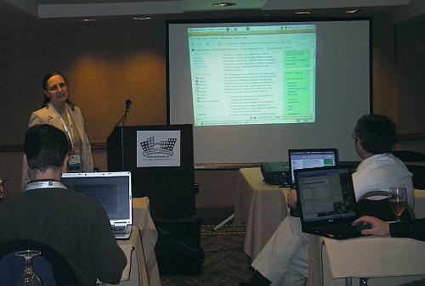
Helena Introduces OSGEO and gives a tour of the OSGEO wiki site
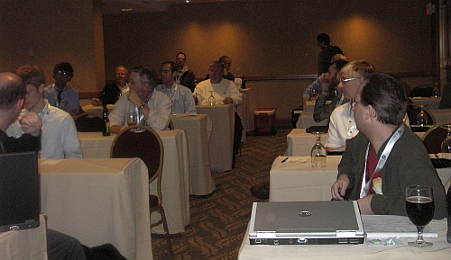
NC OSGEO User Group Attendees

