North Carolina's OSGEO affiliated Open Source GIS user

group holds first meeting at the 2007 NC GIS Conference

Bi-annually, North Carolina GIS professionals hold a statewide GIS conference to showcase their many exemplary projects and initiatives. This year was the 20th anniversary of the NC GIS Conference, one of the nation's oldest state-level GIS events, and had over 950 attendees, 159 presenters, and 58 exhibitors

On March 1st, a small group of dedicated, open-minded GIS professionals led by Dr. Helena Mitasova (of the renowned GRASS project fame) held the first “OSGEO affiliated” NC Open Source GIS user group meeting at the 2007 North Carolina GIS Conference in Winston Salem, NC.

There were approximately 20 attendees, with a majority of the group who signed up for a future listserve being of the University persuasion. There were also a handful of Federal, State and Local Government representatives. Two staff members from an “enormous commercial GIS software provider” also attended.

The informal evening meeting was held after the main GIS conference, and the agenda consisted of the following topics:

- Welcome - Julia Harrell, GIS Coordinator, NC Department of Environment and Natural Resources (NC DENR)

- Short introduction to the OSGEO organization
- Discussion of the NC Affiliated OSGEO user group and its mission. - Dr. Helena Mitasova, Research Associate Professor with North Carolina State University's Department of Marine Earth and Atmospheric Sciences

- Short presentation and demo of QGIS and uDig Open Source Desktop GIS Software. - Doug Newcomb, System Administrator with the US Fish and Wildlife Service's Raleigh, NC Office

- Discussion of potential Open Source GIS Curriculum offerings and a
1-day, hands-on Open Source GIS workshop later this summer. Rodney Jackson, Director of the Geospatial Technology Corporate and Continuing Education Program at Central Piedmont Community College in Charlotte, NC

- Briefing on upcoming 2nd Annual Open Source GIS Conference in San Diego (OSG-SD) at San Diego State University, and a recap of last year's event. - Dana Nibby, GIS Database Analyst with the NC Department of Transportation GIS Unit
- Demo of GAIA3 for Incident Response, a free and interoperable application created with a 2006 FGDC CAP grant by The Carbon Project, NC DENR, the City of Charlotte, and Wake County GIS Departments. - Jeff Harrison, President & CEO, The Carbon Project.
- Announcement of the next day's “Open Source enhanced” GIS Conference presentations – Julia Harrell, GIS Coordinator, NC DENR
“Texas Mesonet: Processing Large Datasets in Real Time,” presented by Gerry Creager, Texas A&M University
“Geospatial Web Services and ScientificWorkflows for Distributing and Modeling Marine Mammal Data,” presented by Dr. Patrick Halpin, Duke University
“Developing the NCCOOS Coastal Data Viewer: Challeges in Real Time Marine GIS”, presented by Jesse Cleary, UNC Chapel Hill
“OpenGIS Web Services and Service Oriented Architecture,” presented by Tobin Bradley, GISP, Mecklenburg County, NC
“Low Cost High Value Web Mapping – a Whirlwind Survey of Free and
Open Source GIS Solutions” - Panel of presenters:

PostgresSQL/PostGIS: Spatially Enabled Relational Databases - Tobin Bradley, GISP, Mecklenburg County NC
PrimaGIS: Collaborative mapping system for Plone CMS - Chris Calloway, UNC Chapel Hill
Web Clients: Community MapBuilder & MapBender - Julia Harrell, NC DENR
Minnesota Mapserver, Chameleon - Tom Melhuish, WebInsights
GRASS GIS – Dr. Helena Mitasova, North Carolina State University
Best of the Rest: GDAL/OGR,CartoWeb, GeoServer , MapGuide Open Source - Doug Newcomb, US Fish & Wildlife Service

“Mashups: The Non-Profit/Community Perspective,” presented by Wansoo Im, The Center for Community Mapping
“Southeastern Gap Analysis: Products and Accessibility,” presented by Todd Earnhardt and Jim White, NC State University
“Econet: NC's Environment and Climate Network for Real-time Weather Modeling” , presented by Ryan Boyles, North Carolina State Climatologist, NC State University
Note: All 2007 NC GIS Conference Presentations will be available for download from the NC GIS Conference website within a few weeks. http://www.cgia.state.nc.us/ncgis2007

Photos from the First Annual NC OSGEO User Group Meeting
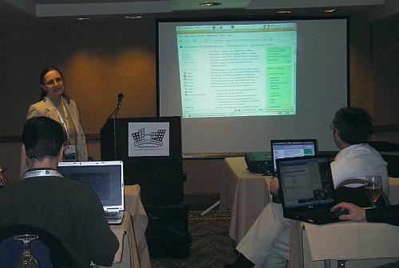
Helena introduces OSGEO and gives a tour of the OSGEO wiki site
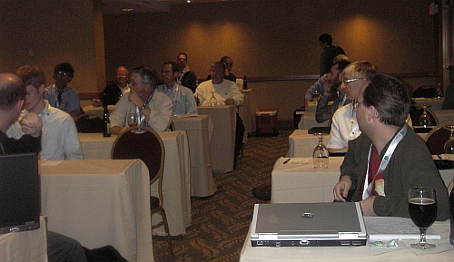
NC OSGEO User Group Attendees

